ASSIGNMENT 10: NETWORKING BASICS

TASK A

Category | IP Address | Binary Format
Address | 192.168.100.4 | 11000000.10101000.01100100.00000100
Network | 28 | 11111111.11111111.11111111.11110000
Network address | 192.168.100.0 | 11000000.10101000.01100100.00000000
Broadcast address | 192.168.100.15 | 11000000.10101000.01100100.00001111
First IP | 192.168.100.1 | 110000000.1010100.01100100.00000001
Last IP | 192.168.100.14 | 110000000.10101000.01100100.00001110
Maximum host in the network | 14

TASK B

Category | IP Address | Binary Format
Address | 170.1.0.0 | 10101010.00000001.00000000.00000000
Network | 26 | 11111111.11111111.11111111.11000000
Network address | 170.1.0.0 | 10101010.00000001.00000000.00000000
Broadcast address | 170.1.0.63 | 10101010.000000001.00000000.00111111
First IP | 170.1.0.1 | 10101010.00000001.00000000.00000001
Last IP | 170.1.0.62 | 10101010.00000001.00000000.00111110
Maximum host in the network | 62

Extra Credit
Write a bash script to print out 0-10 shell scripts by using for loop and while loop, respectively?

FOR LOOP
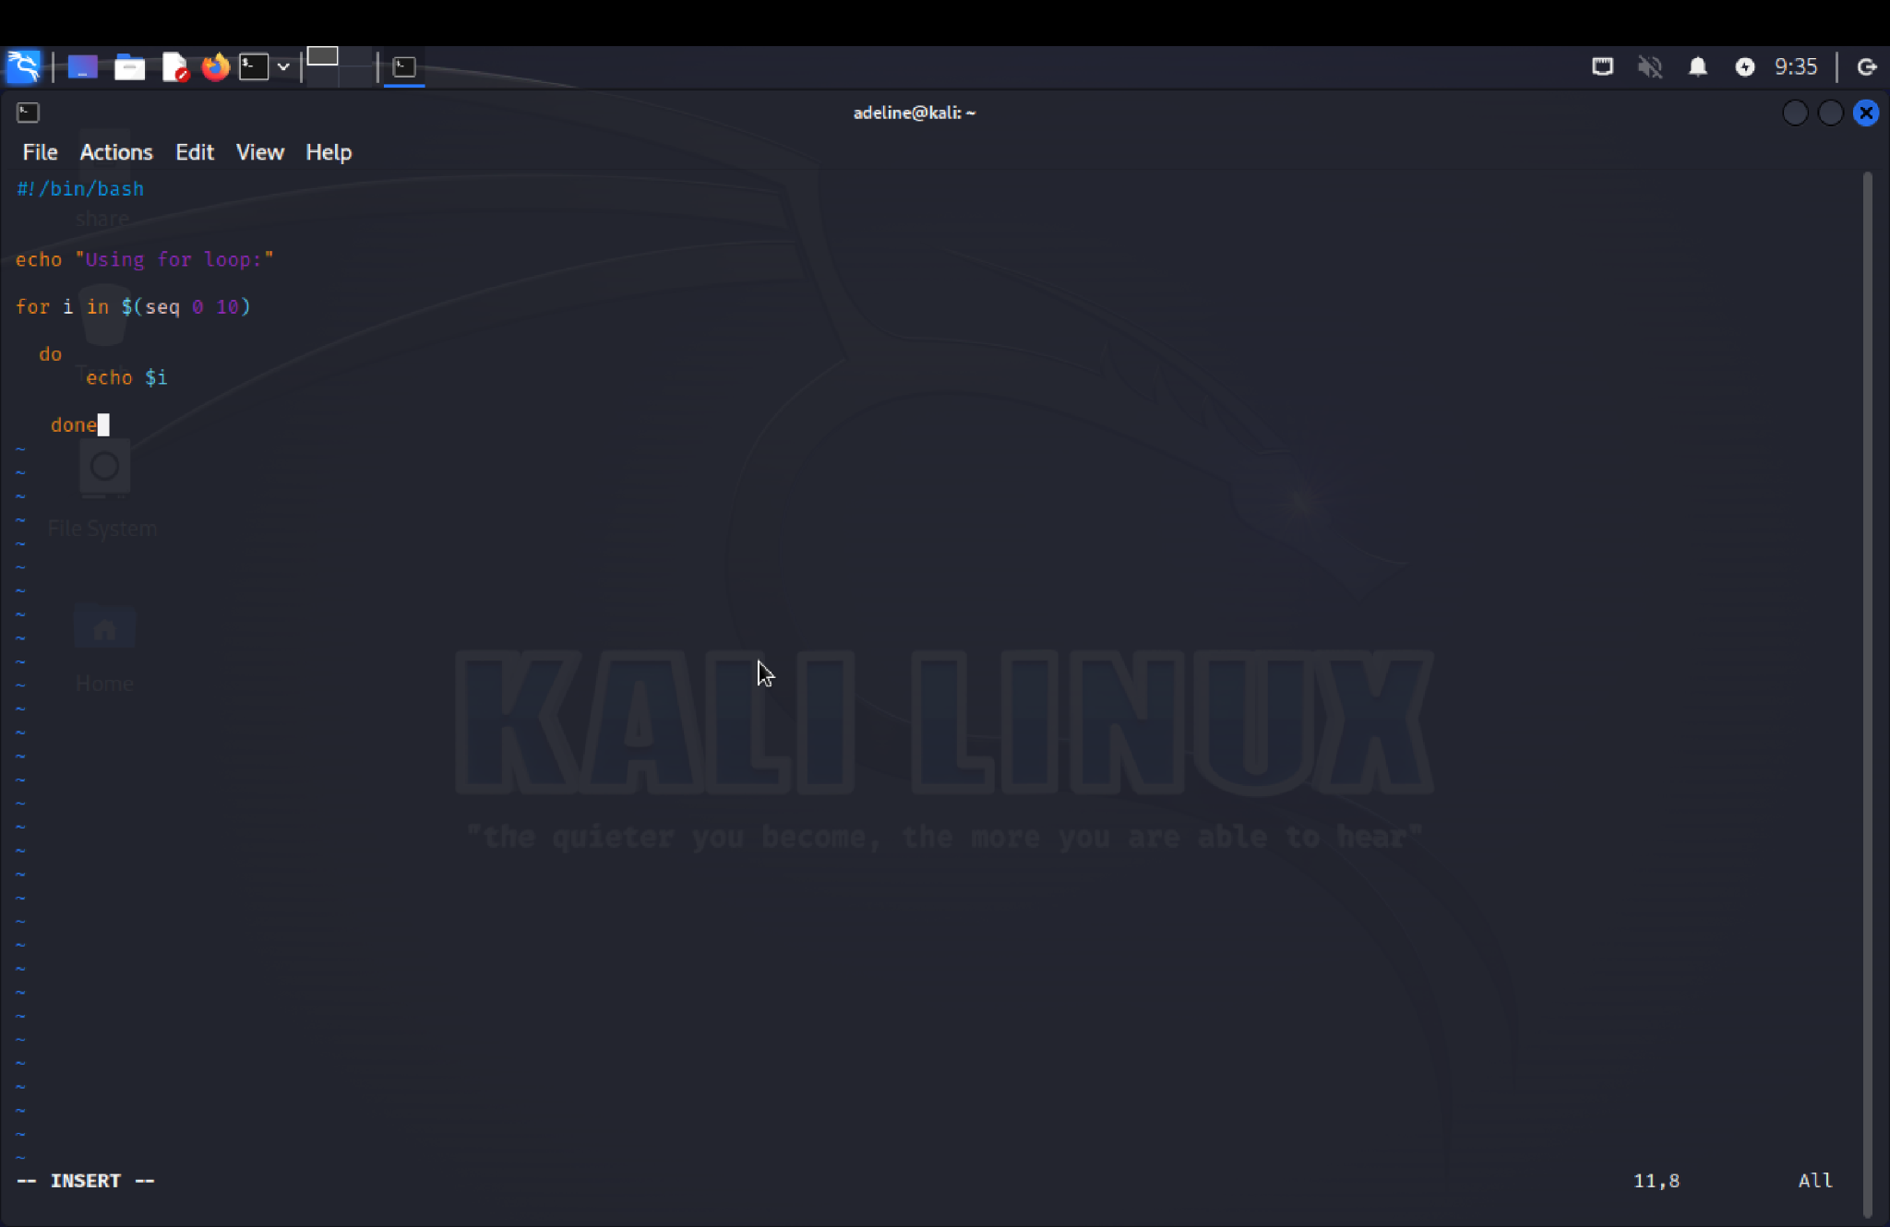

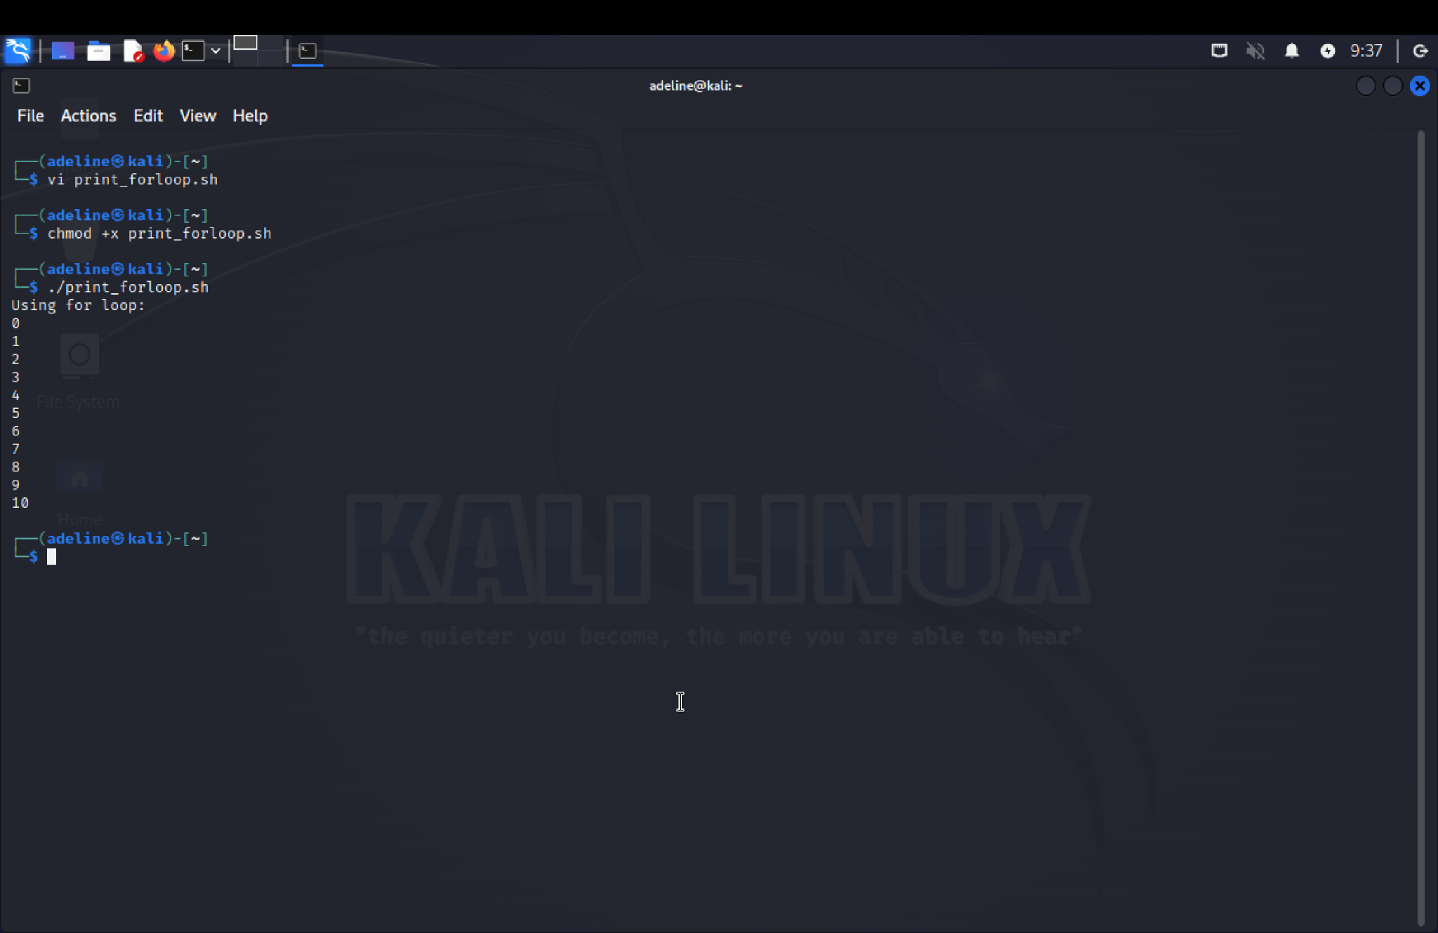
WHILE LOOP
